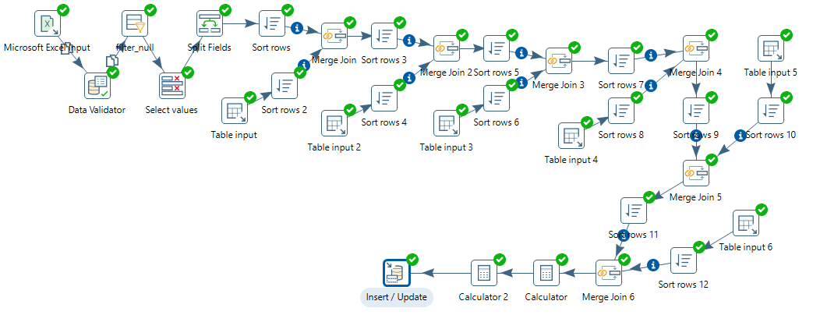

ETL

**Fact table contains auto increment column that is why sequence transformation is not used.**

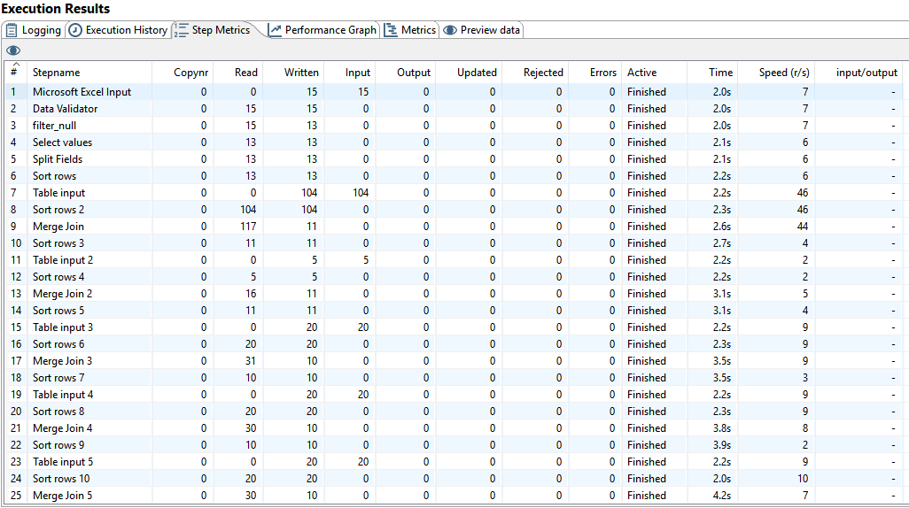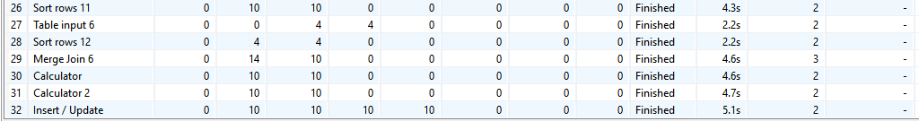

Step metrics

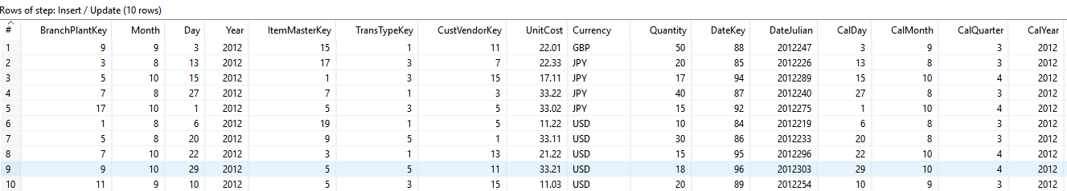

Rows loaded in fact table